January 6, 2016

«first» «last»
«company»
«address12111», «address2111»
«city», «st» «zip»

Dear «first»:
Sometimes the truth is difficult to hear. But the truth of the matter is the homeless veteran situation is real and growing. It is people like Paul, an Air Force Veteran who was living under a bridge for five (5) years, that bring this tragedy to light. Paul, like so many ‘campers’, are living off the grid. They are part of the un-numbered, the un-counted, the forgotten.
The Wichita Police Department’s HOT (Homeless Outreach) Team have been talking to Paul for many years. Paul was discouraged. He tried to get help through the VA and other charities. He was frustrated by the red tape and retreated from society. “I really didn’t intend to be homeless but I just couldn’t wait on the VA to help me. I went several times and was told I had to ‘do this or do that’ and the list kept going”, Paul related.
“When we arrived at the bridge, words cannot describe our feelings. Amazed that anyone could live like this, not to mention with the freezing temperatures”, said Jennifer. “I teared up at the look of his ‘home’. But so thankful that Paul came with us to Passageways”.
After Paul arrived at the living center, he told Jennifer and Sean, “I knew 2015 was the year for change and I told the HOT team to be patient. I just had no idea that there was an option like this (Passageways). I am now ready to see what is next for me.”
«first», for Passageways to continue to assist people like Paul, we need your help. Contribute to our Adopt A Hero program so our mission continues. It is very simple. Just visit www.passagewaysltd.org and click on the Adopt A Hero tab. A monthly contribution of $5, $10 or whatever you are comfortable with helps tremendously.
May God’s blessings be real to you in 2016!
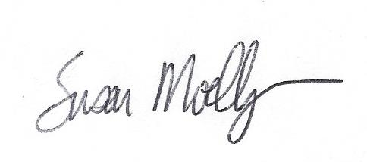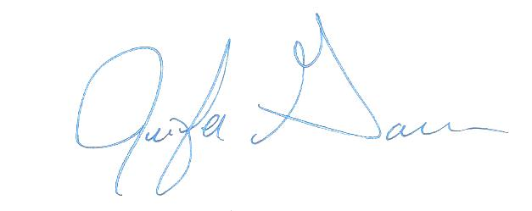
Susan Moellinger Jennifer Garrison
President CEO

PASSAGEWAYSLTD.ORG facebook.com/passagewaysltd TWITTER.COM/PASSAGEWAYSLTD

